


1

Welcome to Schreiner University!
We are happy that your team has chosen to play at Schreiner University located in the beautiful Texas Hill Country, and would like to take this opportunity to inform you of some of the services Schreiner has to offer with this guide.
We encourage you to contact the hotels listed when making reservations for your stay. You will find that these hotels usually offer the best accommodations at the most
affordable prices in the area. Please feel free to share this information with others who
are traveling with your team.
You can access the Official Visitors Guide for Kerrville and the Hill Country area online at http://www.kerrvilletexascvb.com. This guide includes valuable information about local attractions which may help better your experience in Kerrville.
We hope that you will find this information helpful when planning your trip to Schreiner University. If you have additional questions, please feel free to contact any of our athletics department staff members.
We look forward to your visit to our beautiful campus. In the meantime, we wish you and your program continued success.

Table of Contents
Athletics Staff page 4
Coaching Staff page 5
Driving Directions page 6
Directions to Athletics Facilities page 7
Athletics Fields Map & Parking Lot Locations page 8
Game Information by Sport
Page 9
Hotel Listings
page 10
Restaurants
page 11
Emergency Information & Hospital
page 12



Schreiner University Department of Athletics
CMB 6230
2100 Memorial Blvd
Kerrville, TX 78028
830-792-7289 830-792-0639 (Fax)
https://www.schreinermountaineers.com

Administrative Staff

Director of Athletics | Bill Raleigh | 830-792-7482
Associate Director of Athletics | Cindy Becker | 830-792-7310
Admin/Business Manager | Ira Wolfshohl | 830-792-7277
Sports Information Coordinator | Tyler Wells  Tyler Wells | 830-792-7359
Compliance Director  Ryan Brisbin |  | 830-792-7292
Head Athletic Trainer | Jordan Derrick | 830-792-7307
Assistant Athletic Director Development | Jeremiah Tiffin | 830-792-7299
Faculty Athletics Representative | Doug Monk | 830-792-7292

Coaching Staff
Grant Beaver
Steven Beck
Baseball
Head Coach | Ryan Brisbin | 830-792-7292 | rsbrisbin@schreiner.edu
Assistant Coach  Assistant Coach  Assistant Coach | Devin Hooper |  | dhooper@schreiner.edu  GHbeaver@schreiner.edu  sbeck@schreiner.edu
Men’s Basketball
Head Coach | Kyle McLeroy | 830-792-7306 | KPmcleroy@schreiner.edu
Assistant Coach | Albert Almanza |  | ABalmanza@schreiner.edu
Assistant Coach | Roy Kiser |  | RLkiser@schreiner.edu
Women’s Basketball
Women’s & Men’s Cross Country
Women’s & Men’s Golf
Women’s Soccer
Head Coach | Kendra Foreman | 830-792-7381 | Kforeman@schreiner.edu
Assistant Coach | Ashlynn Albert |  | ASalbert@schreiner.edu

Head Coach | Rajeem Garnett | 830-895-7117 | rgarnett@schreiner.edu

Head Coach | Alan Baxter 830-792-7343 | abaxter@schreiner.edu

Men’s Soccer
Head Coach | Darren Bauer | 830-792-7293 | dbauer@schreiner.edu
Assistant Coach | Bryan Wilson |  | BSwilson@schreiner.edu
Assistant Coach

Head Coach | Damien Macias | 830-792-7449 | dmacias@schreiner.edu
Assistant Coach | Cailey Croson |  | CRcroson@schreiner.edu

Softball  Head Coach | Mac Christensen | 830-792-7273 | Mchristensen@schreiner.edu
Assistant Coach | Rick Tovar | 830-792-7370 | rtovar@schreiner.edu
Women’s & Men’s Tennis
Head Coach | Jacob Carrillo | 830-792-7291 | jcarrillo@schreiner.edu
Women’s & Men’s Track & Field
Head Coach | Rajeem Garnett | 830-895-7117 | rgarnett@schreiner.edu
Volleyball  Head Coach | Jeremiah Tiffin | 830-792-7290 | jtiffin@schreiner.edu
Assistant Coach | Hannah Thrasher | 830-792-7378 | hthrasher@schreiner.edu

Football

Head Coach Keith Allen 830-792-7243 KDallen@schreiner.edu

Offensive coordinator David Jones 830-792-7360 Djones@schreiner.edu

Defensive coordinator Shane Hallmark 830-792-7394 phallmark@schreiner.edu

Offensive Line Cody Zwernemann 830-792-7343 cmzwernemann@schreiner.edu

Defensive Line Chris Biggurs 830-792-7329 cbiggurs@schreiner.edu

Men’s Wrestling

Head Coach Jason Rodriguez 830-792-7232 jrodriguez@schreiner.edu

Assistant Coach Manuel Rocha mrocha@schreiner.edu

Women’s Wrestling

Head Coach Troy Jewell 830-792-7341 Tjewell@schreiner.edu

Assistant Coach Alina Kinsey ANKinsey@schreiner.edu

Equestrian

Head Coach Ashley Brune 830-890-1442 Abrune@schreiner.edu

Assistant Coach Megan Delgado-Mitchell Mdelgadomitchell@schreiner.edu

Shotgun

Head Coach Caitlin Connor-Royer 830-792-7474 cconner@schreiner.edu

Rifle

Head Coach Tim McGuire 830-792-7495 TDMcGuire@schreiner.edu

Driving Directions to Schreiner University

From Dallas (271 miles)
- Take I-35 South through Waco toward Austin.
- Go West on Hwy 290 toward Johnson City and continue to Fredericksburg.
- In Fredericksburg, take a left on Hwy 16 South to Kerrville (approximately 23 miles).
From Austin (100 miles)
- Go West on Hwy 290 toward Johnson City and continue to Fredericksburg.
- In Fredericksburg, take a left on Hwy 16 South to Kerrville (approximately 23 miles).
From Houston (250 miles)
- Travel West on I-10 toward San Antonio and continue through San Antonio on I-10 to Kerrville (approximately 55 miles).
From San Antonio (55 miles)
- Travel West on I-10 and take exit 508 in Kerrville , and turn left (south) on Hwy 16 (Sidney Baker Street).
Directions to Schreiner from Hwy 16 and I-10
- From I-10 take exit 508 to Hwy 16 (Sidney Baker Street). Turn left (south) on Hwy 16 and take a left on loop 534 (YO Hotel is on the corner). Continue for approximately four miles.
- Turn right at Hwy 27 (Memorial Blvd.) Continue on Hwy 27 for approximately one mile; turn right into the main entrance to Schreiner University.

Directions Athletic Facilities
Officials: Our official’s locker room is located on the first floor of the Events Center. If you enter through the main doors, go left, past the vending machines, the locker rooms will be on your left. The Athletic Training room is located a little further down on your left from these locker rooms.
Event Center (which includes Stephens Family Arena - basketball and volleyball)
- Inside the campus, turn right at the stop sign. The street curves to the left.
- Once you see the tennis courts stay to the right. The Event Center is located on the left hand side.
Parking is limited in front of the Event’s Center and requested for drop off only. Buses are asked to park in the parking lot next to the Tennis Courts.

Mountaineer Soccer Field
- Inside the campus, turn right at the stop sign. The street curves to the left.
- Once you see the tennis courts stay to the right, parking is located in the tennis court parking lot. The Event Center is located on the left hand side, visiting team locker rooms are located on the second floor of the Events Center.
Parking is limited in front of the Event’s Center and requested for drop off only. Buses are asked to park in the parking lot next to the Tennis Courts.

Baseball and Softball Fields
- Inside the campus, turn right at the stop sign. The street curves to the left.
- Once you see the tennis courts stay to the right.
- Continue straight past the Event Center. The road will lead straight to the fields.

Tennis Courts
- Inside the campus, turn right at the stop sign. The street curves to the left.
- You will see the tennis courts straight ahead along with the tennis parking lot.

Edington Gymnasium (Practice facility)
- Inside the campus, turn right at the stop sign. The street curves to the left.
- Once you see the tennis courts take the left towards the pool. Just after the pool, Edington Gymnasium is located on the right hand side with parking in front.
Buses are asked to park in the parking lot next to the tennis courts or in front of the Mountaineer Fitness Center and Event Center.
Please contact athletics@schreiner.edu with any questions or concerns you may have.

Athletics Fields Map & Parking Lot Locations

Green Parking Lot – Tennis Court Parking Lot
Blue Parking Lot – Event Center and Mountaineer Fitness Center Parking Lot Orange Parking Lot – Additional Bus Parking

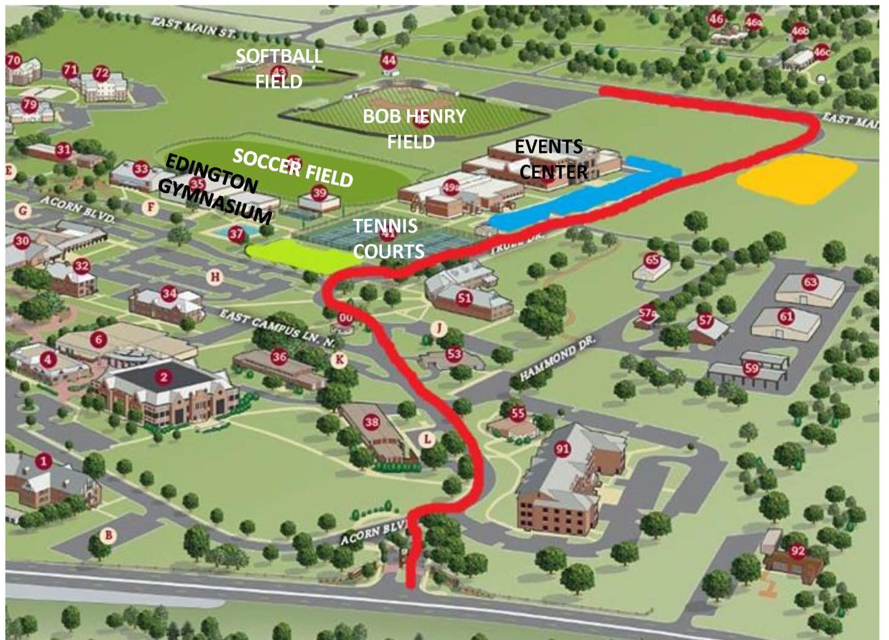
Soccer Field moved to right of the event center

Parking at Yellow in top right corner

Game Information by Sport

Volleyball
Volleyball matches will be held in the Event Center. Visiting locker rooms will be assigned on arrival and will be located on the second floor of the Events Center. Practices prior to game day will need to be scheduled with the coaching staff unless otherwise noted.

Men & Women’s Soccer
Soccer games will be held on the soccer game field. Visiting locker rooms will be assigned on arrival and will be located on the second floor of the Events Center. Showers will be available in the Event Center after each game. Practices prior to game day will need to be scheduled with the coaching staff unless otherwise noted.

Men & Women’s Basketball
Basketball will be held in the Event Center. Visiting locker rooms will be assigned on arrival and will be located on the second floor of the Events Center. Practices prior to game day will need to be scheduled with the coaching staff unless otherwise noted.

Baseball
Baseball games will be held on the Bob Henry Field. Showers will be available in the Event Center after each game. Practices prior to game day will need to be scheduled with the coaching staff unless otherwise noted.

Softball
Softball games will be held on the Mountaineer Softball Field. Showers will be available in the Event Center after each game. Practices prior to game day will need to be scheduled with the coaching staff unless otherwise noted.

Men & Women’s Tennis
Tennis matches will be held at the George and Frances Cree Tennis Complex. Practices prior to game day will need to be scheduled with the coaching staff unless otherwise noted.

Golf
The Schreiner Spring Shootout will be held at the Club at Comanche Trace. Practices prior to game day will need to be scheduled with the coaching staff unless otherwise noted.

Athletic Training Facilities
The athletic training room is located in the Event Center on the first floor. Athletic Trainers will be available throughout each event held on Schreiner University campus. Please bring your own tape and supplies.

Please note that towels will not be provided.

Officials

Our official’s locker room is located on the first floor of the Events Center. Enter through the main doors, continue past the vending machines, the door will be on the left. The Athletic Training room is a little further down on your left from these locker rooms.


Hotel Listings

Y.O. Ranch Resort Hotel  2033 Sidney Baker St.  Kerrville, TX 78028 | La Quinta Inn & Suites  1940 Sidney Baker St.  Kerrville, TX 78028
Inn of the Hills Resort  1001 Junction Hwy  Kerrville, TX 78028 | Best Western  2124 Sidney Baker St.  Kerrville, TX 78028
Quality Inn & Suites 2001 Sidney Baker St. Kerrville, TX 78028 | Holiday Inn Express 2114 Sidney Baker S. Kerrville, TX 78028
Hampton Inn  2038 Sidney Baker St  Kerrville, TX 78028 | Motel 6 Days Inn  1810 Sidney Baker St.  Kerrville, TX 78028

Restaurants
Jersey Mikes
704 Junction Hwy
830-315-6453
10 AM- 9 PM

Subway | Subway | Bumdoodler’s Sandwich
207 Sidney Baker South | 228 Junction Hwy | Shop 1312 Broadway
830-792-4445 | 830-792-5565 | 830-315-2867
7 AM- 11 PM | 7 AM- 11 PM | 10 AM- 6 PM
Chicken Express | Chick-Fil-A | Church’s Chicken
624 Sidney Baker St | 1060 Junction Hwy | 206 Sidney Baker South
830-315-2750 | 830-257-6901 | 830-257-3333
10:30 AM-10 PM | 6 AM- 10 PM | 10:30 AM- 10 PM
Chili’s Bar & Grill | Bella Sera | Dickey’s Barbecue Pit
1185 Junction Hwy | 2124 Sidney Baker St | 881 Junction Hwy
830-895-2445 | 830-257-2661 | 830-792-0757
10:45 AM- 10 PM | 7 AM- 9 PM | 11 AM- 9 PM
Cracker Barrel | Schlotzsky’s | Bella Vita
2110 Sidney Baker St | 1423 Sidney Baker St | 1550 Junction Hwy
830-896-7808 | 830-895-3354 | 830-895-0820
6 AM- 10 PM | 10 AM- 9 PM | 11 AM- 9 PM
Ringos | Papa John’s Pizza | Domino’s Pizza
1421 Junction Hwy | 2262 Bandera Hwy | 305 Sidney Baker St.
830-895-5050 | 830-896-7272 | 830-257-6700
11 AM- 11 PM | 10 AM- 10 PM | 10:30 AM- 12 AM
Jimmy John’s | Raising Cane's | Billy Genes  1489 Junction Hwy  830-895-7377  11AM- 8:30 PM
603 Main St. B | 1201 Junction Hwy | Billy Genes  1489 Junction Hwy  830-895-7377  11AM- 8:30 PM
830-896-3333 | 830-257-3974 | Billy Genes  1489 Junction Hwy  830-895-7377  11AM- 8:30 PM
11 AM- 10 PM | 10 AM - 11 PM  10 AM - Midnight (Fri/Sat) | Billy Genes  1489 Junction Hwy  830-895-7377  11AM- 8:30 PM

Emergency Information

Schreiner University Campus Security  830-739-1111 | Peterson Regional Medical Center  551 Hill Country Dr.  830-896-4200
Kerrville Police Department Emergency  911 | Kerrville Police Department Non-Emergency  830-257-8181  429 Sidney Baker St.

